

**Home |** [**About Us**](https://nimitinfo.000webhostapp.com/aboutus.php) **|** [**Contact Us**](https://nimitinfo.000webhostapp.com/contactus.php)

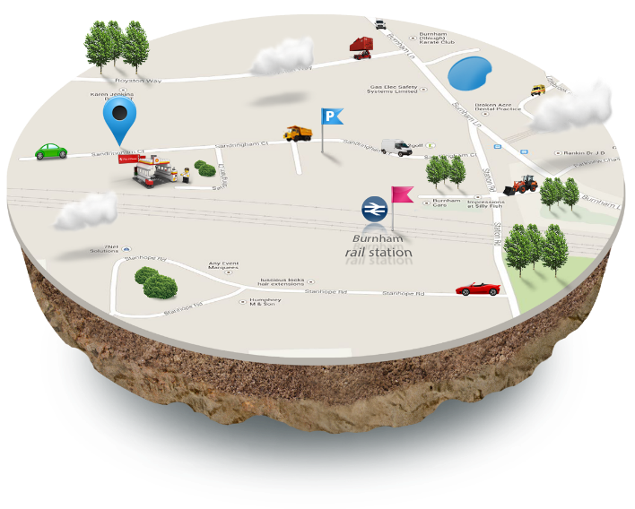

**About US**

Sarvam Automation leads in effective telecommunications and information as well as M2M (Man to Machine, Mobile to Machine) solutions for all kinds of Movable Asset Management. We deliver flexible and cost-effective solutions based on ICT (Information and Communication Technologies), GPS (Global Positioning System), wireless, and web technologies. Our solutions enable customer to track effective position, status, working hours of his movable assets. We design, build, and support our solutions from our development and control center in India. Strong in-hour R&D team, manufacturing capabilities and valuable references are strength of Sarvam Automation.

Sarvam Automation provides solutions in Industries, Commercials, Transport and Corporate as well as consumers market too.

**Welcome to Sarvam Automation**

Sarvam Automation leads in effective telecommunications and information as well as M2M (Man to Machine, Mobile to Machine) solutions for all kinds of Movable Asset Management. Sarvam delivers flexible and cost-effective solutions based on ICT (Information and Communication Technologies), GPS (Global Positioning System), wireless, and web technologies. Our solutions enable customer to track effective position, status, working hours of his movable assets.

We design, build, and support our solutions from our development and control centre in India. Strong in-hour R&D team, manufacturing capabilities and valuable references are strength of Sarvam Automation.

**Solutions**



Fleet management is the management of a company's vehicle fleet. Fleet management includes commercial motor vehicles such as cars, vans and trucks.

[**More...**](https://nimitinfo.000webhostapp.com/fleet_management.php)

[](https://nimitinfo.000webhostapp.com/heavy_eauipment_management.php)

Sarvam Automation HEM provides solutions for fleet managers to manage heavy equipment’s working in out-sight of construction as well as agriculture.

[**More...**](https://nimitinfo.000webhostapp.com/fleet_management.php)



[](https://nimitinfo.000webhostapp.com/taxi_dispatch.php)

Real-time tracking to monitor actual customer pick-up and drop-off times, unsafe driving, excessive idling, and unauthorized vehicle use.

[**More...**](https://nimitinfo.000webhostapp.com/fleet_management.php)



[](https://nimitinfo.000webhostapp.com/bus_management.php)

All the features required for real-time public transportation fleet tracking, plus advanced utilities to monitor unsafe driving, excessive idling, adherence to scheduled routes, and tardiness.

[**More...**](https://nimitinfo.000webhostapp.com/fleet_management.php)



**Fleet Management Solutions**

Fleet management is the management of a company's vehicle fleet. Fleet management includes commercial motor vehicles such as cars, vans and trucks. Fleet (Vehicle) management can include a range of functions, such as vehicle telematics (tracking and diagnostics), vehicle financing, vehicle maintenance, driver management, fuel management and health & safety management.

copyright © 2013 sarvamautomation.com

Sarvam Automation FMS is a GPS, GSM, GPRS based wireless solution for managing fleet vehicles. A vehicle tracking system unit is installed inside the fleet. That VTS unit automatically sends tracking updates based on its individual time interval when fleet’s engine ON or OFF. Each tracking updates contains fleet’s GPS based location, fleet’s moving, idle, stop or lost GPS status, I-Pos FMS also helps to monitor the fleet’s performance, driving behavior, can send real-time alert notifications if any emergency problem occur.

Sarvam Automation FMS is a web based and easy to use solution. It provides current status of all fleets, list of fleets on map, historical reply of individual fleet, location reports, alert reports, fuel usage reports, utilization information, fleet history logs and more.

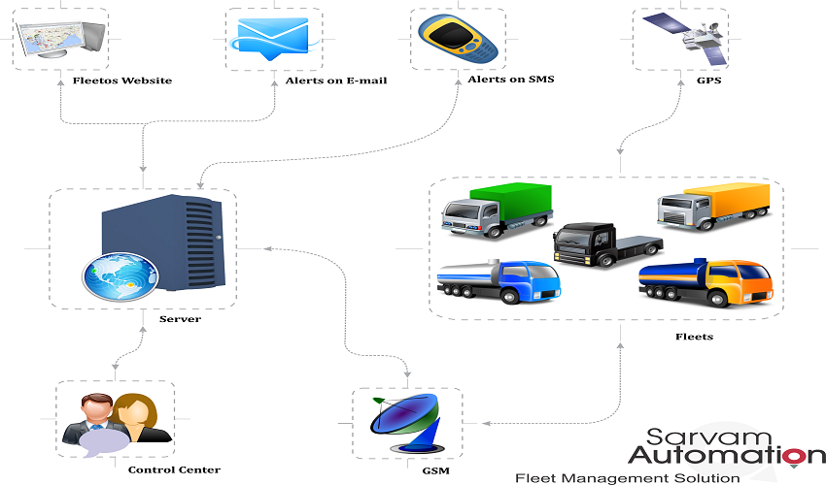Sarvam Automation **Fleet Management System Features**

In Sarvam Automation FMS: A vehicle tracking system unit is installed inside the fleet. The VTS unit automatically sends tracking updates based on its individual time interval when fleet’s engine ON or OFF. The tracking updates time interval can be customized as per user’s requirements. Each tracking updates contains fleet’s GPS based location, fleet’s moving, idle, stop or lost GPS status as well as speed, location, engine status and many more.

Sarvam Automation FMS user can view fleets **current** –show where the fleets are located now and **historical** – where the fleets have been in past.

Sarvam Automation FMS user can do **Real-Time Monitoring** as well as **Remote Controlling** to get current fleets status as well as remotely control fleets by sending configuration command as well as control commands.

Sarvam Automation FMS **Daily Activity Report** contains all history of respected fleet of requested date.

Sarvam Automation FMS **Engine On-Off Report** in which user can list of all engine on-off alerts of fleet including date-time and place name.

Sarvam Automation FMS **Fleet Working Hour Report** contains fleet’s information regarding start time, end time, start location, end location, total travel time as well as travelled mileage.

Sarvam Automation FMS **Fleet Working Hour Summary Report** contains all summary of work hour reports include work hours as well stop hours for all fleets.

Sarvam Automation FMS **Alerts Report** in which user can list of all alerts occurred in fleet. With the help of alert reports user can have better idea of fleet driver’s driving behavior.

Sarvam Automation FMS **Waypoint Report** in which user can specify up to 65 locations called Waypoints, when each fleet approaches and/or departs each waypoint. For example, a fleet has to pass through customer’s sight, warehouses, construction sites, farms as well as fields.

Sarvam Automation FMS **Geofence Report** in which user can specify up to 65 area called Geofence, when each fleet approaches and/or departs each geofence. We can define time base geofence in which we can schedule fleet’s time in which fleet must have to enter or exit in geofence on preconfigured time interval.

Sarvam Automation FMS **Fuel Usage Report** in which use can see the fuel usage in chart. By the list of fuel use in report user can get clear idea for **fuel injection** in fleet as well as **fuel pilferage** in fleet. Fuel usage report may contain list of fuel injection alerts and fuel pilferage alerts too.

Sarvam Automation FMS **Mileage Report** in which user can have better idea for driver’s driving behavior, impotence in maintenance and effective cost reduction using expense reports.

Sarvam Automation FMS **Over Speed Report** in which contains list of all over speed alerts, using that user can justify driver’s driving behavior, impotence in maintenance.

Sarvam Automation FMS **Alert Notifications**, if any high priority event occurs, Sarvam Automation FMS give real-time notifications as Text Message as SMS or notification can also send via Email. Sarvam Automation FMS high priority alerts listed below:

**» Engine ON, Engine Off**

**» Second Engine ON, Second Engine Off (if fleet have)**

**» Speed Violation – Over Speed**

**» Geofence Enter, Geofence Exit**

**» Low Battery, Battery Connect, Battery Disconnect, Battery Tamper**

**» Backup Battery Connect, Backup Battery Disconnect, Backup Battery Tamper**

**» Curfew Violations – generate alert when fleet engine turns on during a prohibited time period**

**» Fuel Injection, Fuel Pilferage**

**» GPS Antenna Connected, GPS Antenna Disconnected, GPS Antenna Tamper**

**» Waypoint Enter, Waypoint Exit**

**» Enable Power Saving Mode, Disable Power Saving Mode**

Using Sarvam Automation FMS **web interface all reports** as well as **alerts** easily accessible. By logged in to website of Sarvam Automation user can get latest of information of all fleets. All alert notification on **SMS** or **Email** can easily get on demand by enabling on request to control center.

Sarvam Automation FMS also provides **Schedule Reports** based on Individual fleets, group of fleets as well as customer wise all fleets.

Schedule reports can easily get on demand by enabling on request to control center. Schedule report contains all history of fleets for each running day and it will be generated on each day end.

**Heavy Equipment Management Solutions**

Sarvam Automation HEM provides solutions for fleet managers to manage heavy equipment’s working in out-sight of construction as well as agriculture. It is quite difficult for fleet manager to manage all dispersed heavy equipment’s in different sites at a time. It is also difficult to track machine, working hours, maintenance. Based on this information project manager comes to know about billing, invoicing, maintenance and for other business purpose too. In a general manner all information are collecting manually. Because of inefficient, time-consuming, error-prone information, wasted manpower, under-utilization, misplacement, faulty maintenance and occasionally catastrophic failure or theft many enterprises may lose their assets value.

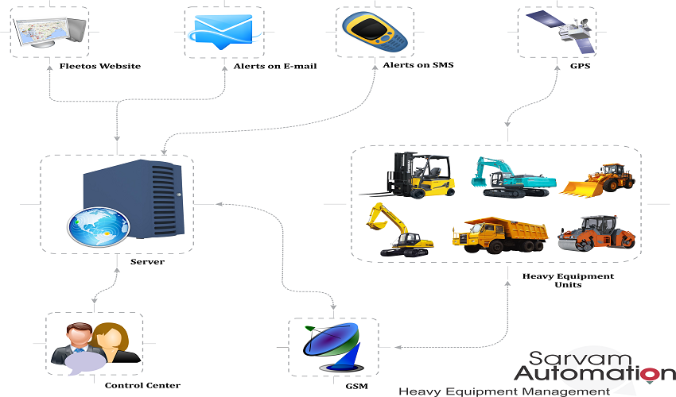Sarvam Automation HEM is a GPS, GSM, GPRS based wireless solution for managing fleet vehicles. A vehicle tracking system unit is installed inside the fleet. That VTS unit automatically sends tracking updates based on its individual time interval when fleet’s engine ON or OFF. Each tracking updates contains fleet’s GPS based location, fleet’s moving, idle, stop or lost GPS status, I-Pos HEM also helps to monitor the fleet’s performance, driving behavior, can send real-time alert notifications if any emergency problem occur as well as engine running/working hour.

**Sarvam Automation Heavy Equipment Management System Features**

In Sarvam Automation HEM: A vehicle tracking system unit is installed inside the fleet. The VTS unit automatically sends tracking updates based on its individual time interval when fleet’s engine ON or OFF. The tracking updates time interval can be customized as per user’s requirements. Each tracking updates contains fleet’s GPS based location, fleet’s moving, idle, stop or lost GPS status as well as speed, location, engine status and many more.

Sarvam Automation HEM user can view fleets**current**–show where the fleets are located now and historical – where the fleets have been in past.

Sarvam Automation HEM user can do **Real-Time Monitoring** as well as **Remote Controlling** to get current fleets status as well as remotely control fleets by sending configuration command as well as control commands.

Sarvam Automation HEM Daily **Activity Report** contains all history of respected fleet of requested date.

Sarvam Automation HEM **Engine On-Off Report** in which user can list of all engine on-off alerts of fleet including date-time and place name.

Sarvam Automation HEM**Fleet Working Hour Report** contains fleet’s information regarding start time, end time, start location, end location, total travel time as well as travelled mileage.

Sarvam Automation HEM **Fleet Working Hour Summary Report** contains all summary of work hour reports include work hours as well stop hours for all fleets.

Sarvam Automation HEM **Alerts Report** in which user can list of all alerts occurred in fleet. With the help of alert reports user can have better idea of fleet driver’s driving behavior.

Sarvam Automation HEM **Waypoint Report** in which user can specify up to 65 locations called Waypoints, when each fleet approaches and/or departs each waypoint. For example, a fleet has to pass through customer’s sight, warehouses, construction sites, farms as well as fields.

Sarvam Automation HEM **Geofence Report** in which user can specify up to 65 area called Geofence, when each fleet approaches and/or departs each geofence. We can define time base geofence in which we can schedule fleet’s time in which fleet must have to enter or exit in geofence on preconfigured time interval.

Sarvam Automation HEM **Fuel Usage Report** in which use can see the fuel usage in chart. By the list of fuel use in report user can get clear idea for fuel injection in fleet as well as fuel pilferage in fleet. Fuel usage report may contain list of fuel injection alerts and fuel pilferage alerts too.

Sarvam Automation HEM **Mileage Report** in which user can have better idea for driver’s driving behavior, impotence in maintenance and effective cost reduction using expense reports.

Sarvam Automation HEM **Over Speed Report** in which contains list of all over speed alerts, using that user can justify driver’s driving behavior, impotence in maintenance.

Sarvam Automation HEM **Alert Notifications**, if any high priority event occurs, Sarvam Automation HEM give real-time notifications as Text Message as SMS or notification can also send via Email. Sarvam Automation HEM high priority alerts listed below:

**» Engine ON, Engine Off**

**» Second Engine ON, Second Engine Off (if fleet have)**

**» Speed Violation–Over Speed**

**» Geofence Enter, Geofence Exit**

**» Low Battery, Battery Connect, Battery Disconnect, Battery Tamper**

**» Backup Battery Connect, Backup Battery Disconnect, Backup Battery Tamper**

**» Curfew Violations – generate alert when fleet engine turns on during a prohibited time period**

**» Fuel Injection, Fuel Pilferage**

**» GPS Antenna Connected, GPS Antenna Disconnected, GPS Antenna Tamper**

**» Waypoint Enter, Waypoint Exit**

**» Enable Power Saving Mode, Disable Power Saving Mode**

**Bus Management**

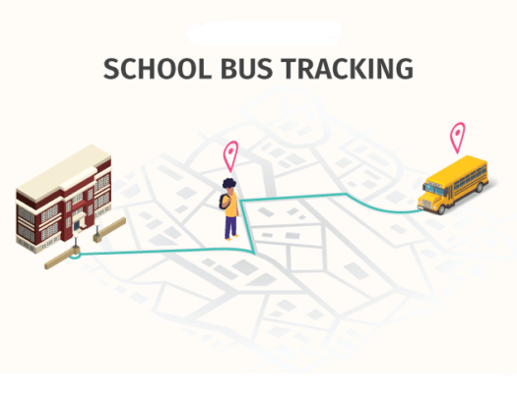

copyright © 2013 sarvamautomation.com

* **Description**

School buses are under pressure to not only provide a safe,

reliable service to school children and their parents,

but also, to run efficiently and provide a profitable return

to the bus service for the school.

* **why School Bus Tracking**

**>** Student's safety

> Vehicle alert for parents

> Alert on parents by vehicle arriving & departing late

> Cost Savings

> Time Management

> Better maintenance

> Two - Way communications

**1 Vehicle Tracking**

Sarvam Automation VTS is a GPS, GSM, GPRS based wireless solution for managing vehicles. A vehicle tracking system unit is installed inside movable asset. That VTS unit automatically sends tracking updates based on its individual time interval when vehicle’s engine ON or OFF. Each tracking updates contains vehicle’s GPS based location, vehicle’s moving, idle, stop or lost GPS status, Sarvam Automation VTS also helps to monitor the vehicle’s performance, driving behavior, can send real-time alert notifications if any emergency problem occur.

Sarvam Automation VTS is a web based and easy to use solution. It provides current status of all vehicles, list of vehicles on map, historical reply of individual fleet, location reports, alert reports, fuel usage reports, utilization information, fleet history logs and many more.

To ensure Sarvam Automation VTS successful operation and maintenance a basic plan is created. Sarvam Automation VTS System configuration is developed. Control Login diagram are prepared and automation system is examined with dynamic simulation study. Sarvam Automation offers VTS services with remote units, central equipment with special software to translate GPS data on digitized maps, setting of network structures, training courses onsite and tech support for your projects.

We offer Sarvam Automation VTS Services with System Engineering, Project Evolution, Operations, Implementation, Testing, Installation, Training, Upgrades.

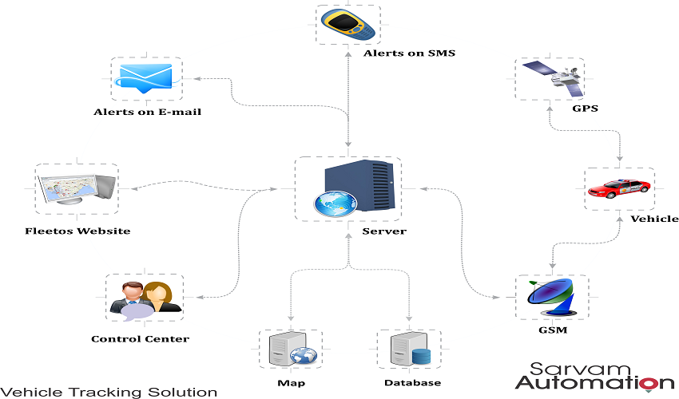

copyright © 2013 sarvamautomation.com

**Personal Tracking**

**Get ready for the maximum tracking and peace of mind**

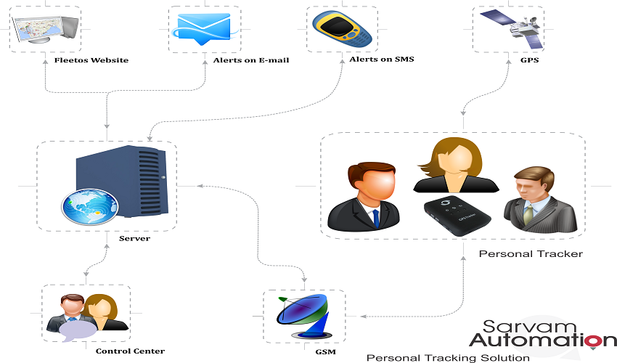The Sarvam Automation PTS is a portable GPS tracking device that can be used as an emergency cellular phone and allows speed dialing of 2 numbers for two-way voice communication. The Sarvam Automation PTS Personal tracker sends a total of 4 alerts in the event of an emergency. Alerts include help me message and automatically pick the call if any of the 4 preset numbers call.

copyright © 2013 sarvamautomation.com

**Real-time Monitoring**

Know the exact location of loved ones, workers & pets

Respond timely to Emergency events with real time tracking

**Safety**  
Two-way communication

Lone-worker functionality – panic buttons

Reduce risk of your pets being lost or run away

**Parolees Monitoring**

* Used to monitor the parolees
* Set the geo-fence for parolees and know in time if left the geo-fence
* Quick check on their location.

**Main Features**

* Rechargeable Li-Ion battery
* Dual communication mode SMS/GPRS
* USB data port for configuration and GPS output
* Individual Geo-Fence capability with reporting
* Data logger built-in to record time stamp, speed, position, heading, and event state
* Remote over-the-air configuration via GSM
* Real-time dynamic reporting based on time interval
* Over speed alerting accumulator built-in
* 2 sets pre-set dial out tel. no.
* Parking button
* Pickup and Hang up call button
* SOS button for emergency help

**Benefit**

**Save Fuel / Manage your fuel**

Our system helps fleet manager to find out the consumed quantity of fuel per vehicle per day. This information gives brief idea regarding fuel consumption in trip time or in off time. It also helps to know about fuel refill and fuel pilferage as report and also in alert.

**Increased Productivity**

Some time it happens that hours worked and hours claimed by driver may vary, our system helps to eliminate discrepancies using key reports like Activity report, Daily work hour report.

**Reduce Overtime**

To avoid false timesheet claims, our system proved real time vehicle tracking with accurate start and stop times with idling time and total number of stops too.

**Lower Fuel Costs**

By eliminating unapproved extended journeys our system can reduce your fuel bill with Vehicle fuel summary report.

**Reduced Private Use**

Our system can instantly raise alerts on SMS as well as in Email for any movement of vehicle in unapproved working hours.

**Faster Response Time**

Our system helps to deploy vehicle based on prediction of arrival times or delays with greater speed.

**Reduce Communication Cost**

Our system helps to monitor your vehicles 24X7 on screen, so you can reduce phone call charges to your driver to get the current vehicle positions.

**Custom Reports**

We provide integration services to tailor the GPS solution to your business including Customized reports that match your company's data format, measure statistics unique to your business or industry.

**Support**

**Technical Support**

In current business trends, all industries rely on their information system to run their operation efficiently. If it becomes unavailable, operations will be interrupted or crashed. It is essential to provide a reliable infrastructure for IT operations to reduce any change of disruption. For Information security concern, our all operational servers in an offsite certified data centre. The data centre offers a secure environment and guaranteed up time where Sarvam Automation web services, hosted applications and database servers are operational.

Sarvam Automation provides the high-quality hardware and reliable services at a reasonable cost. Sarvam Automation proper IT structure and knowledgeable / experienced staff satisfies the need of its clients with excellent service. Our developers help not only to give the right solutions, but also gives right solution to grow the client’s business.

**Support by email**

Our technical support team is always ready to respond your all queries in email on [sarvamautomation@gmail.com](mailto:sarvamautomation@gmail.com)

**Support by web**

Our web support allows you to Get latest news, updates and support services as well as to Access an extensive online database of user manuals, technical papers, FAQ's, newsletters, and more

**Service Plan**

Sarvam Automation services are available in different plan, service plan can be tailored based on the customer’s requirement. Please contact our Sales representative today for more information. (Contact URL)

**To use our services**

To use our services, contact our Sales representative today for pricing and more information. (Contact URL)

**Installation**  
Professional and experienced engineers do the installation in order to reduce down time. Normally installation process takes approximately one hour per vehicle. Our experienced engineers can do the device installation securely without damaging the vehicle interior as per customer’s requirement.

**Product Training**

Professional experienced trainers are available to support users with all their software needs. Sarvam Automation has trainers available to answer everything from simple software related questions to complicated enterprise issues. Available remotely or on-site within seven days a week, please contact our support team to serve you better. (Contact URL)

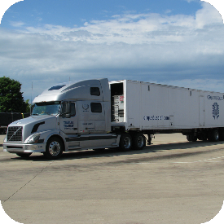**Sarvam Automation Customized Solutions**

**Heavy Equipment Management Solution:**

A solution allows operators to reduce operating coast and protect assets equipment failure and theft by monitoring critical machine operating parameters link status of equipment, easily determining location and service hour data, reports, fuel usage reports as well as second engine running report and more.

**Personal Tracking Solution:**

A portable GPS tracking device that can help you to know the exact location of loves ones. workers & pets. Respond timely to Emergency events with real time tracking, speed dialling of 2 numbers for two-way voice communication. Personal tracker sends a total of alert in the event of an emergency.

**Vehicle Tracking Solution:**

Vehicle Tracking Solution web based and easy to use solution. It provides current status of all sarvam automation, list of sarvam automation on map, historical reply of individual fleet, location reports, alert reports, fuel usage reports, utilization information, fleet history logs and more.

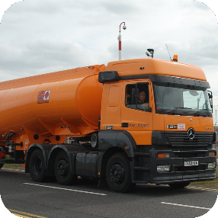

**Fleet Management Solution:**

A Solution which shows current status of all sarvam automation, list of sarvam automation on map, fleet monitoring. historical reply of individual fleet, location reports, alert reports, fuel usage reports, utilization information, fleet history logs and more.

**Container Tracking Solution:**

Container tracking solutions helps to determine the current positions of containers in cargo on the world map. Long life internal battery inside the CTS unit helps operator to track containers real time.

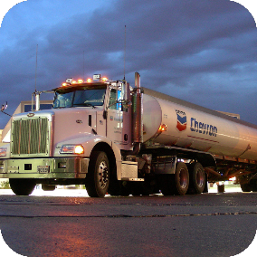

**Fuel Monitoring Solution:**

Fuel theft is a major problem for all fleet manager. Fuel monitoring solution helps to monitor in each fleet’s fuel usage. Fuel pilferage and Fuel refill and reserve and also send SMS based Real time alerts on mobile as well as in E-mail.

***Keep security in mind. It saves your business***

**AIS 140 GPS Trackers**

| **Index** | **Device** | **Manufacturer** |
| --- | --- | --- |
| 1 | [Satcop AIS 140](https://www.uffizio.com/gps-tracker/satcop-ais-140/) | [Satcop](https://www.uffizio.com/manufacturer-category/satcop) |
| 2 | [Gagan-01](https://www.uffizio.com/gps-tracker/gagan-01/) | [Roadpoint Limited](https://www.uffizio.com/manufacturer-category/roadpoint-limited) |
| 3 | [AIS 140 NIC](https://www.uffizio.com/gps-tracker/ais-140-nic/) | Libi Technologies |
| 4 | [Bharat 101 SOC](https://www.uffizio.com/gps-tracker/bharat-101-soc/) | [iTriangle](https://www.uffizio.com/manufacturer-category/itriangle) |
| 5 | [Bharat 101](https://www.uffizio.com/gps-tracker/bharat-101/) | [iTriangle](https://www.uffizio.com/manufacturer-category/itriangle) |
| 6 | [IAC](https://www.uffizio.com/gps-tracker/iac/) | [Indian Auto Company](https://www.uffizio.com/manufacturer-category/indian-auto-company) |
| 7 | [IAC 140-IR](https://www.uffizio.com/gps-tracker/iac-140-ir/) | [Indian Auto Company](https://www.uffizio.com/manufacturer-category/indian-auto-company) |
| 8 | [IAC 140 CAN](https://www.uffizio.com/gps-tracker/iac-140-can/) | [Indian Auto Company](https://www.uffizio.com/manufacturer-category/indian-auto-company) |
| 9 | [GB140](https://www.uffizio.com/gps-tracker/gb140/) | [GPSBOX](https://www.uffizio.com/manufacturer-category/gpsbox) |
| 10 | [Cello-CANiQ](https://www.uffizio.com/gps-tracker/cello-caniq/) | [Cellocator](https://www.uffizio.com/manufacturer-category/cellocator) |
| 11 | [TM77](https://www.uffizio.com/gps-tracker/tm77/) | [Blackbox](https://www.uffizio.com/manufacturer-category/blackbox) |

**-:Menu:-**

1. Sarvam solutions
2. About
3. Service
4. Products
5. Member (Office Staff)
6. Gallery
7. Contact us

# Product Details: Fuel Level Sensor Our range of products include GPS fuel sensor.

|  |  |
| --- | --- |
| Brand | MIELTA |
| Model Number | Fantom |
| Model | Fantom |
| Type | Float Fuel Sensor |
| Flange Material | Stainless Steel |
| Accuracy | up to 99% |
| Input | 12 to 24 V DC |
| Operating Temperature | -40 to + 80 Deg C |
| IP Protection Class | IP67 |
| Colour | Black |
| Battery | Li-SOCL2, 3.6V |
| Application | Truck |
| Dimension | 80 x 80 x 25 mm |
| Network Type | Bluetooth Low Energy5.0 |
| Memory | 4 Mb |

1. **Mielta Fantom** combines satellite monitoring trends that provide reliability and stability of operations even under difficult operating conditions: on uneven topography and in unstable communications.
2. The device is equipped with an innovative system of self-diagnostics: a unique integrated meter based on the obtained data is able to inform about the reasons of deviations in operation (incorrect calibration, change of fuel properties, water discharge).
3. The built-in accelerometer detects the vehicle inclination level, which can be used to validate the fuel level data.  
     
   The adaptive energy saving system allows the device to save energy consumption during storage and transportation in a horizontal position. Communication stability is achieved by means of a high-efficiency built-in antenna.  
     
   **Technical characteristics**

|  |  |
| --- | --- |
| POWER SUPPLY | Battery Li-SOCL2 3.6 ??, 2.7 ??*?? |
| MEASUREMENT PERIOD | from 1 to 10 sec |
| ADVERTISING PERIOD | from 1 to 10 sec |
| AVERAGING INTERVAL | from 1 to 60 |
| RELATIVE MEASUREMENT ERROR | No more than 1% |
| DATA TRANSFER FORMAT | 0 – Mielta   1 – analog ??? 1 |
| WIRELESS TRANSMITTER | Bluetooth Low Energy 5.0, 2.4 GHz |
| TRANSMITTER POWER | Adjustable, up to 8 dBm |
| TILT ANGLE MEASURER | Inbuilt accelerometer, +/- 1G α°=arcsin (Z/127) |
| TEMPERATURE MEASURER | inbuilt, +/-2 |
| INBUILT MEMORY | 4 ??b |
| WIRELESS SOFTWARE UPDATE AND CONFIGURATION | YES |
| INGRESS PROTECTION | IP67 |
| EXPLOSION PROTECTION MARKING | 0ExiaIIBT6X |
| OPERATING TEMPERATURE | from - 40 to +85 °C |
| LIFETIME | 7 years |
| MEASUREMENT LENGTH | 990 /1490 /1990 |
| HOUSING DIMENSIONS | 80 80 25 |
| SENSOR DIMENSIONS | 80 80 1015 |



**Contact us**

**Company Details:**

**Sarvam Automation**

11, Bhailalbhai Park,

B/h. Manav Dharma Ashram, Manjalpur, Vadodara-390011, Gujarat, India

Mobile No: +91 972-699-9499, +91 972-476-7018

E-Mail ID: sarvamautomation@gmail.com

Web: www.sarvamautomation.com

